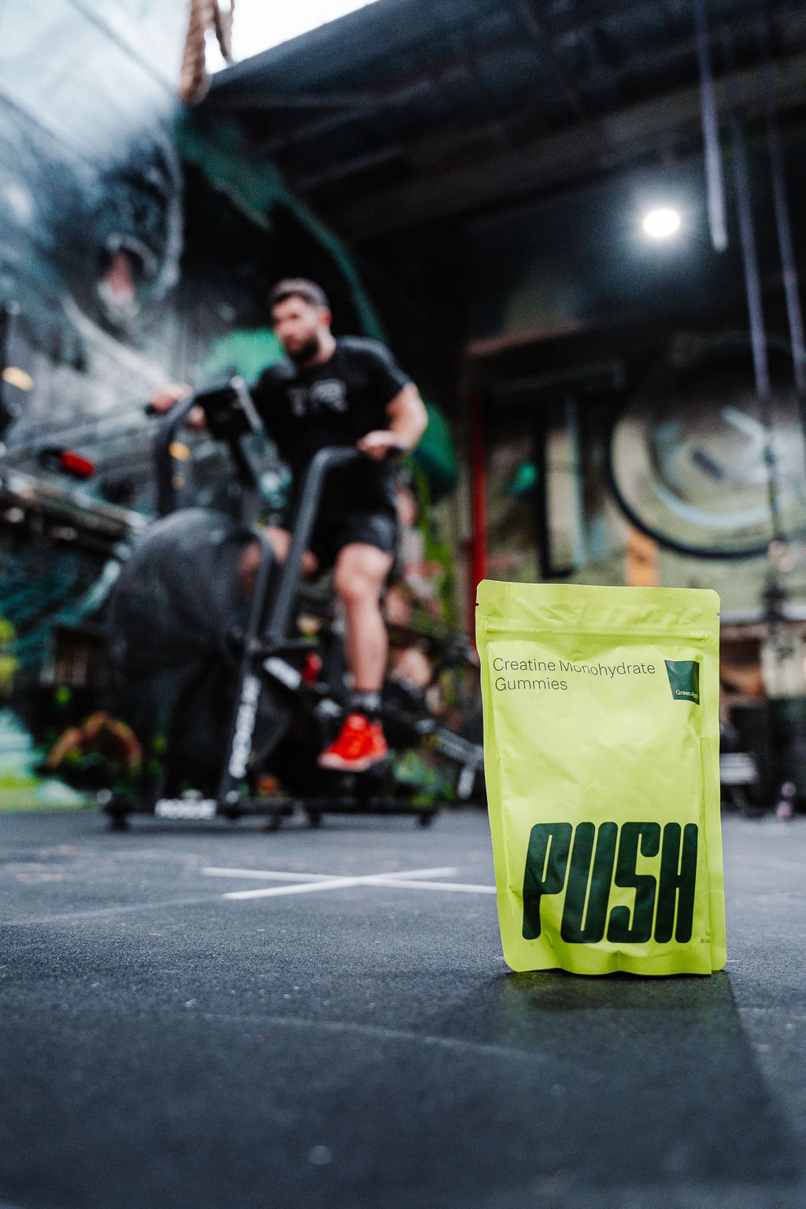
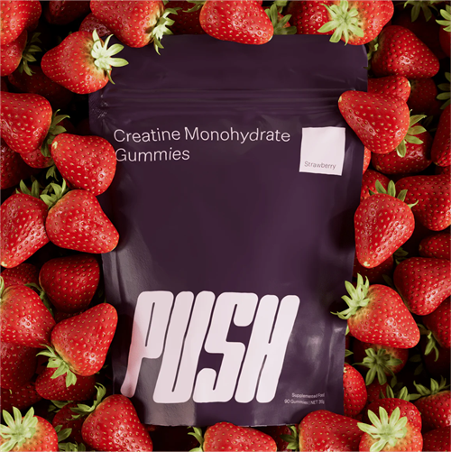
PUSH The New Way to Take Creatine
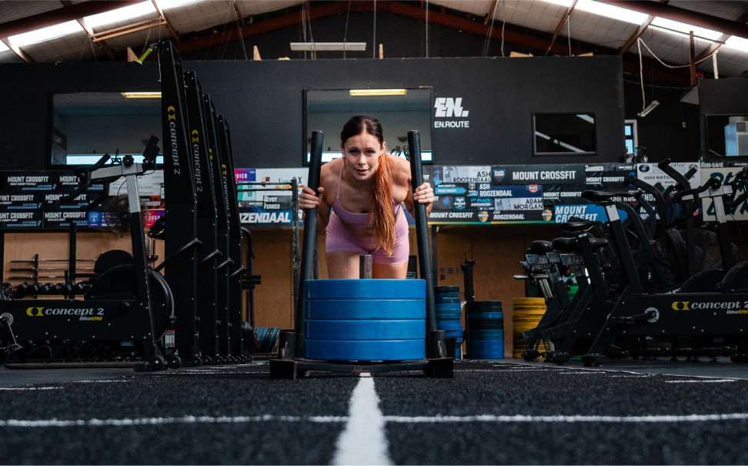
Improved Muscle Size and Strength
Creatine enhances muscle size and strength by increasing phosphocreatine stores in your muscles. This boosts ATP production, providing energy for exercise and workouts and leading to good gains in muscle size and power.

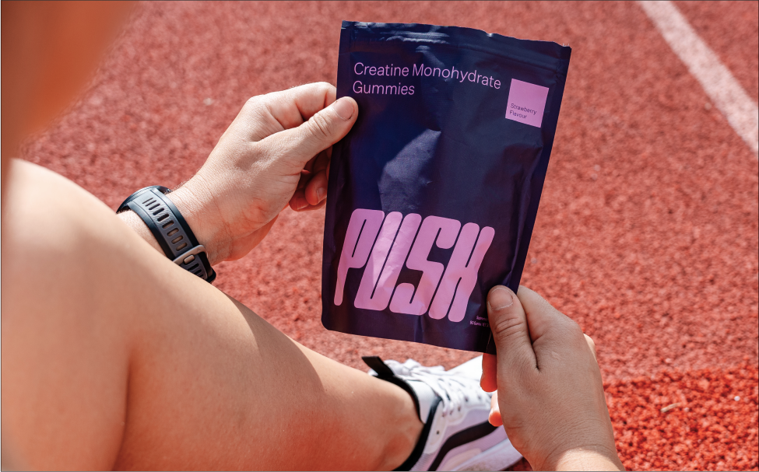
Enhanced Athletic Performance
Known to improve athletic performance, creatine increases energy availability and reduces fatigue. This allows you to train harder and longer, enhancing your overall physical performance and endurance.


Faster Recovery Times
Creatine accelerates muscle recovery by reducing muscle cell damage and inflammation following intense exercise. This helps you bounce back quicker from workouts, reducing downtime and allowing for more consistent training.


Cognitive Benefits
Creatine supports brain health by improving cognitive function and memory. It increases the production of ATP in brain cells, enhancing mental clarity, focus, and overall cognitive performance.

For best results:
Take FOUR gummies per day ANY time of day EVERY day
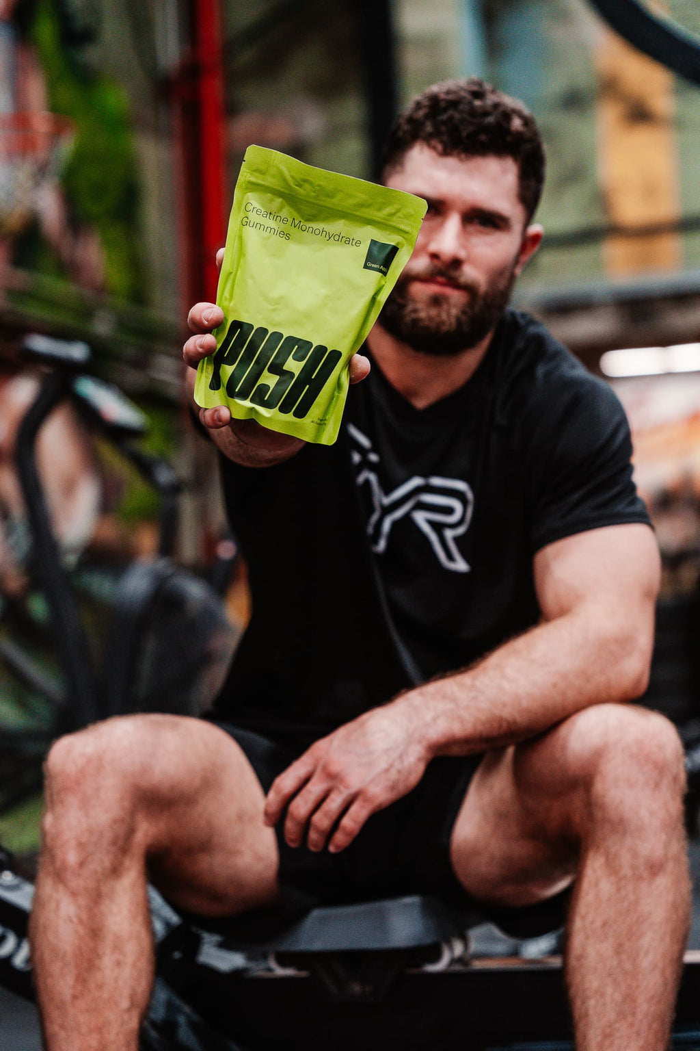

How it works
Four gummies contain 5g of creatine, your daily dose. Each bag has 90 gummies, your monthly supply.

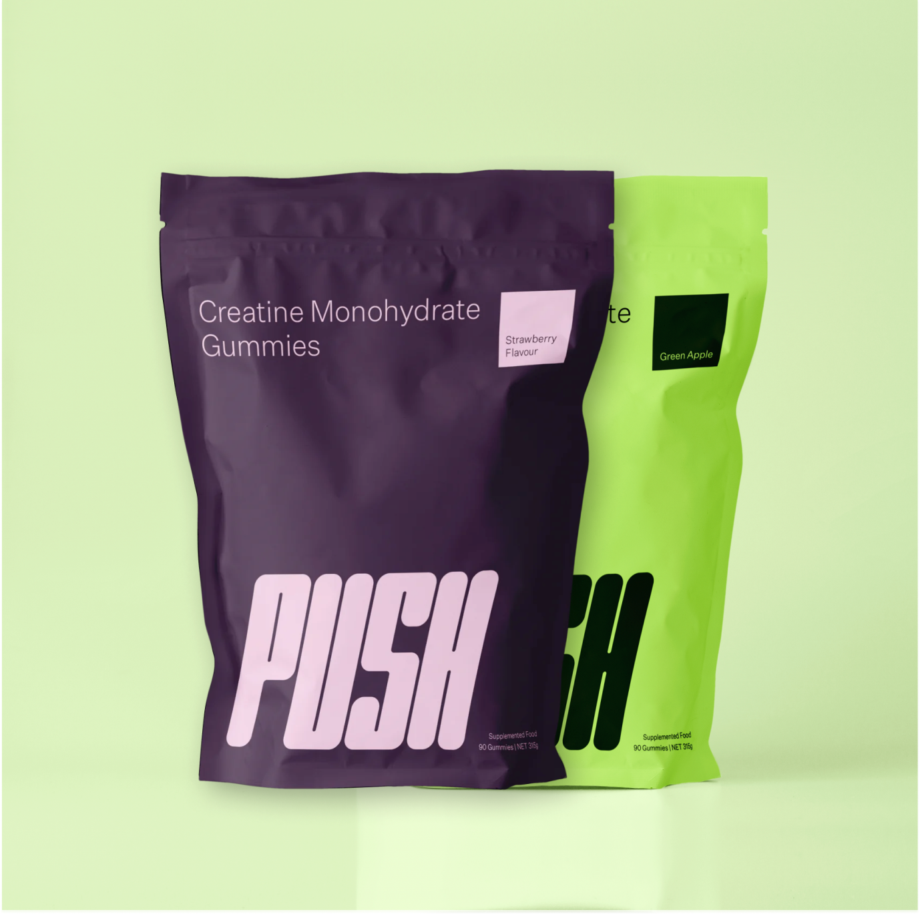

What to expect
Improvements in Strength, Recovery, and Performance within 3 to 4 weeks.



LABORATORY TESTED SUPPLEMENTS
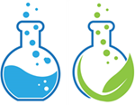
FORMULATED SUPPLEMENTARY SPORTS FOOD

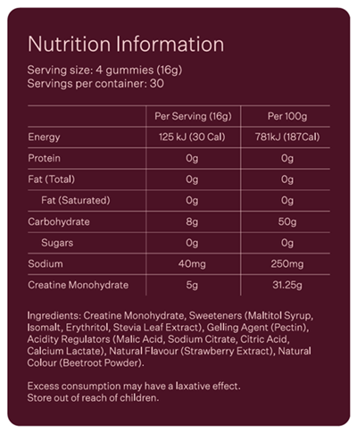

Safety Information:
• This product should always be used as directed - never exceed recommended serving dose for a 24 hour period.
Note(s):
Excess consumption may have a laxative effect - Store out of reach of children

This product is not a medicinal drug and should not be used to treat symptoms of any disease
† This product is not intended to diagnose, treat, cure or prevent any disease.
Individual results may vary.

