High Strength Plant Sterols 2400mg per Serving (120 Vegan Tablets) Beta-Sitosterol Formula to Lower Cholesterol - Heart & Cardiovascular Support – Suitable for Vegans

About this item
- Plant Sterols High Strength 2,400mg Daily Serving – Clinically proven to lower LDL (“bad”) cholesterol, support heart health, and help maintain healthy blood lipid levels.
- Plant Sterols to Lower Cholesterol Triple-Action Cardiovascular Support offer broad cardiovascular support while also contributing to a well-functioning immune system.
- Flexible Daily Dosage – Take 1 to 3 tablets daily: 1 tablet (800mg) to maintain normal cholesterol levels, or 3 tablets (2,400mg) to help actively reduce cholesterol.
- Ideal for Men & Women Seeking Natural Cholesterol Support Without Statins. 120 Tablets Per Pouch – Provides a 1-to-4-month supply depending on your chosen daily intake.
- BioPharmX: Pure, pharmaceutical-grade supplements are formulated using only the highest-quality ingredients for exceptional purity, strength, and effectiveness.
- Manufactured in the UK in a fully certified facility, adhering to the highest industry standards for safety, quality, and consistency.

Important information
Ingredients:
Plant Sterols
Directions:
Take 1 to 3 tablets daily: 1 tablet to maintain normal cholesterol levels, or 3 tablets (2,400mg) to help actively reduce cholesterol.

Product Description
BioPharm-X Plant Sterols – Natural Support for Heart Health & Cholesterol Levels
Take control of your heart health with BioPharm-X Plant Sterols, expertly formulated to support normal cholesterol levels and promote cardiovascular wellness. Each tablet delivers a potent dose of natural plant sterols (phytosterols), compounds scientifically proven to help reduce LDL (bad) cholesterol when taken as part of a balanced diet.
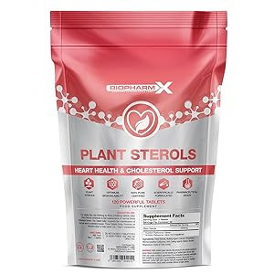

BioPharm-X Plant Sterols Key Benefits
- Supports Healthy Cholesterol Levels
- Clinically Proven to Reduce LDL Cholesterol
- Heart Health & Cardiovascular Support
Plant Sterols work by blocking cholesterol absorption in the intestines, helping you maintain healthy blood lipid levels naturally. Ideal for anyone managing cholesterol or seeking to improve overall cardiovascular health.
- Manufactured in the UK in a fully certified facility, BioPharmX ensures every tablet meets the highest standards of purity, potency, and quality.
- Eco Packaging: Compact, letterbox-friendly pouch designed for minimal environmental impact

BioPharm-X: Superior Standards in Nutritional Supplements

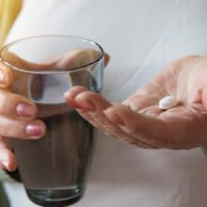

Flexible Dose
Take 1 to 3 tablets daily, preferably with meals.
- 1 tablet per day (800mg) contributes to the maintenance of normal blood cholesterol levels.
- 3 tablets per day (2400mg) provide the clinically effective dose to actively lower cholesterol.

Do not exceed stated dose in a 24-hour period.
Use only as directed.


Pharmaceutical Quality
Manufactured within an MHRA, FDA and GMP approved facility for your highest level of safety, BioPharm-X supplements meet strict pharmaceutical-grade standards.
- Formulated with pure, high-strength ingredients for maximum efficacy
- Produced to the highest safety and quality benchmarks
- Trusted, transparent, and independently verified



Eco-Friendly Packaging
BioPharm-X has a commitment to sustainability.
- Designed with sustainability and convenience in mind
- Fits through your letterbox — no missed deliveries
- Minimal plastic use


Pure & Powerful Formula
Manufactured with premium grade Plant Sterols to support heart health and cholesterol balance.
- Free from GMOs and artificial additives
- Clean-label formula for safe, long-term daily use
- Scientifically supported to reduce cholesterol absorption when combined with a healthy lifestyle
- No fillers — just effective, research-backed ingredients



